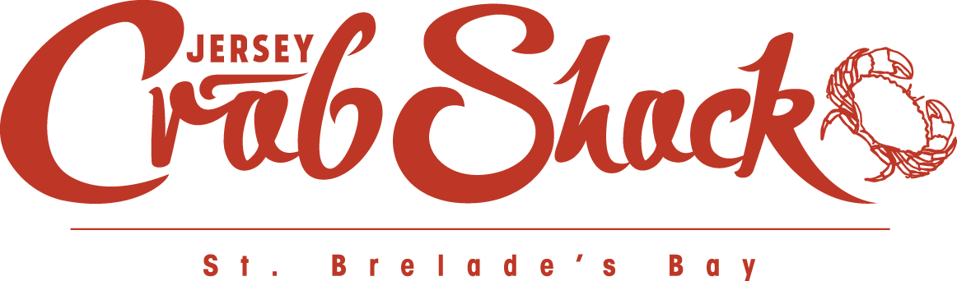

CONFIRMATION NUMBER: TABLE BOOKED FOR:  
1a2345b6 Wed, 4 Jan, 2017 at 6:00pm

We have **cancelled** your reservation at Jersey Crab Shack St. Brelade as requested. If you did not intend to cancel your reservation, please contact us on +441534850855 or via [stbrelade@jerseycrabshack.com](mailto:stbrelade@jerseycrabshack.com).

|  |  |
| --- | --- |
| **Name** | Hayley Routier |
| **Restaurant** | Jersey Crab Shack St. Brelade |
| **Party of** | 4 |

We look forward to welcoming to you to Jersey Crab Shack St. Brelade or another [JPRestaurants location](http://jprestaurants.com/) soon.

**[](http://jprestaurants.com/)**Have you visited our other [JPRestaurants locations](http://jprestaurants.com/)?

Link to http://jprestaurants.com/

**[](http://jprestaurants.com/)**Jersey Crab Shack St. Brelade  
St. Brelade’s Bay  
St. Brelade, Jersey, Channel Islands  
JE3 8EF  
Tel: +441534850855  
E-mail: [stbrelade@jerseycrabshack.com](mailto:stbrelade@jerseycrabshack.com)   
Website: [www.jerseycrabshack.com](http://www.jerseycrabshack.com)